The Cathars, a threat to the Catholic Church?
By Harry Long

The Cathars were cast away from the Medieval Catholic Church. They were generally based around Southern France, main cities that had a large population of Cathars are Beziers,Carcassone and Bram. They were cast aways because of the fact that they had a different point of view of the Catholic Church. They were called the Cathars after the word Katheroi which is “the pure ones” in ancient greek. They thought it was corrupt and evil. The Cathars thought it was the Devil that created the earth and that we had to pray to god in order to rescue us from the world the devil created. Whereas the Catholics thought it was God who created the earth and that humans were spoiling the nature of the world (this commonly thought among other religions, this made the Cathars unique in a certain way). The main reason why they disagreed with Christianity was because they thought that the whole point of the Catholic Church was the worship the cross – and from a point of view death. The also believed that when you die you are re-incarnated into a different being e.g a butterfly or a cow. This lead to the conclusion that you shouldn’t eat animals because you may eat your Grandmothers re-incarnated soul in a cow. This would then be a form of cannibalism – which is illegal. One of the major differences from the Catholic Church was also the equality to women. Even though men are physically strong they (unlike the catholic church.) thought that women had the right to equality because they are just as intelligent and have to give birth to children.
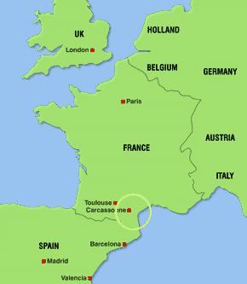
Carcassone was a based in a very good strategic position. It was close the borders of Spain and Barcelona so if the time came when they would have to flee Carcassone, it would be relatively easy to cross the border. It was also near Tolosa so some of the things that this city provided was very accessible. Tolosa was well known for being the pink city because of the large amounts of clay that surrounding the area. Albi could supply Pastel which was a blue dye. This would of only been given out to the rich but using it would of shown a sign of wealth. The fortress of Carcassone was on a raised hill so that the lord of the castle can overview the surrounding land and the peasants as the work the land. The earth in Carcassone was very fertile and easy to grow crops and raise animals on. This meant that food wouldn’t often been short, unless an attacking enemy shuts them inside the fortress where there is no land and they would then starve to death. Carcassone was also rather close to the ocean so water was accessible and people from different countries can trade with them via the ocean.

When you are excommunicated by the church you are no longer aloud the receive communion, whilst this might seem like a small thing in the present day back in Medieval Era this would have effected your entire life. It was like banishing you from any society. In addition your life would have been at great risk from religious fundamentalists. Furthermore, God (in the eyes of the church) would not recognise you. This is one of the worst thing that could happen to a Catholic because it means all the work you have been doing to get up to Heaven is lost so you are an enemy of the church. At the start of Pope Innocents III ‘s reign his main goal was to defeat the threat of Catharism. He would be regularly sending in missionaries and persuading the local authority to act against them. But, in 1208 the Popes messenger was killed after declaring Count Raymond VI of Toulouse, no longer a member of the church. At this point, the Pope declared the Abigenisan Crusade. I think that the Pope would have excommunicated the Cathars first because it was a severe warning and another way of saying that you are no longer part of the church and that they were the enemies.

Simon de Montfort was like the modern day Islamic State fundamentalists. He was ruthless. If he had the option to kill 500 Cathars, kill all the nobles or kill everyone in the city; he would kill all the habitants of the city. This proves the queote “History repeats itself.” The siege was a period during the Abigenisan Crusade when Simon de Monfort fort for the control of Carcassone Castle. One of the main features of this battle was when Raymond – Roger de Tentcavel of Carcassone agreed with Simon de Monfort for a peace negotiations. Simon happily agreed however, as Raymond turned his back to return to the castle, Simon de Monfort had him shot. This had a huge effect of the city of Carcassone. It left them without a leader. This started a little civil war in the walls of Carcassone, who would be leader? Simon de Monfort took advantage of the situation and attacked. In the end the people of Carcassone fought against him and Simon was killed by a Mangonel operated by a little kid. A stone was made showing the life of Simon de Monfort, this can be found in the Church of Carcassone.
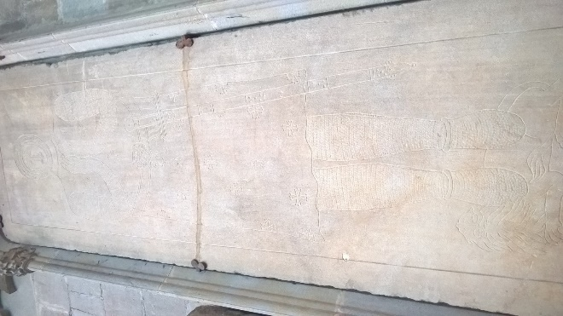
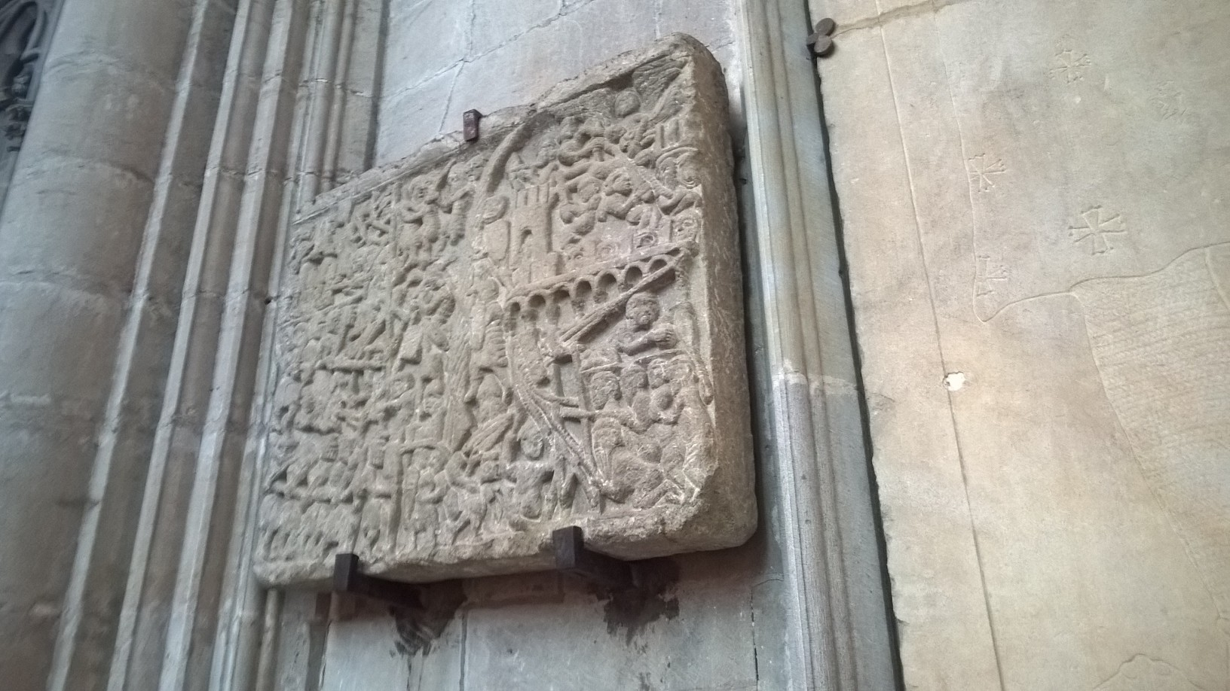

Siege Stone – Picture taken by Harry
Long
The Siege Stone represted the life of Simon Monfort – Leader of the Albigenisan Crusade 1209 – 1229. He died leading the Crusade against the Cathars. He was killed when a Mangonel operated by a little kid, hurled a rock at his head and exploded his skull, everywhere. If we were to look at Simon de Monfort we can see a strong resemblance to Islamic State fundamentalists. He was ruthless and he was involved in a religious war – killing those who didn’t believe in what he believed in.

In conclusion I think the Cathars are very different from the Catholic Church and at the time of Pope Innocent III they were a definite threat to the Catholic Church. I think they were right in lots of aspects especially in the Women’s equality. However, from my point of view they went a little bit crazy with the whole “reincarnated” thing. You need to eat meat to have a good diet. But, most people back then didn’t even get the opportunity to eat meat because they were so poor. All in all (from my point of view) I think the Cathars were better, however, there were aspects I wouldn’t have liked.

