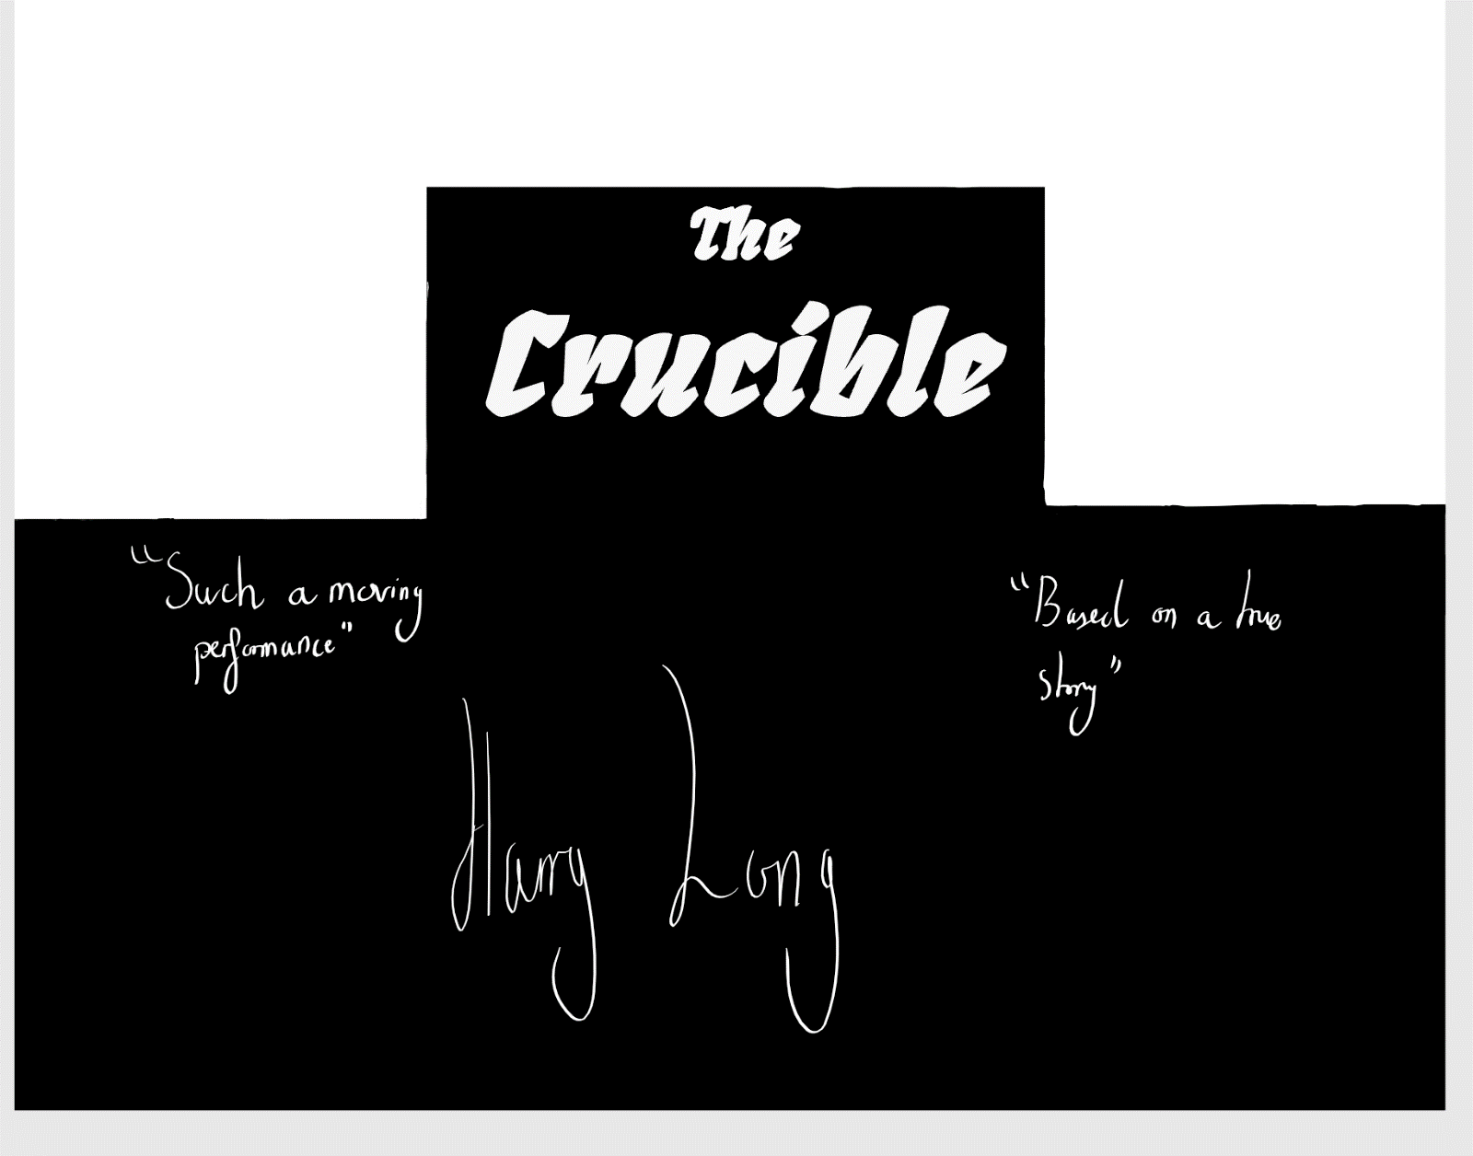
Directors’ Notes
Written by Arthur Miller
Directed by Harry Long
8X
06/03/2017

Pages 45 to 48

Contents -

History and Context of the Novel and the Summary of the Extract – Page Three
Significance of the Extract and Key Dramatic Moments – Page Four
Character Development - Pages Five, Six and Seven
Extra Parts in the Play - Page Eight
Set Design and Props – Page Eight
Costumes – Pages Nine and Ten
Lighting – Pages Eleven and Twelve
Sound – Pages Twelve
Annotated Script – Pages Thirteen, Fourteen and Fifteen

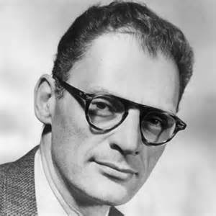
History and Context
The Crucible was a story written by Arthur Miller. It is based off a true incident but was further developed to show a view he wanted to get across to his readers in America and everywhere else in the world due to the political errors of his time. Court papers were found, showing of a mass killing of innocent people. This large group of people were charged of being a witch. Some confessed and lived, others did not. Arthur Miller worked on improving the story and later came out with the book “The Crucible”. Arthur Miller was married to the famous actress Marilyn Monroe with who, he created books and then films. Due to her reputation, these books and films took off, making him the famous man he is today. However, he was living in the time of McCarthyism. This was a dangerous time as the leader – President Truman – ordered lists to be created highlighting any individual with the possibly links to communism. If they were found to indeed have communist relations, they were locked up or even killed! The result of these large lists was the imprisonment of many innocent people. Arthur Miller was accused of such links because of some of the political views he showed in his books and films. In order to show the world what a corrupt time period they were living in, he wrote a book illustrating the times in an understandable, relatable manner. He wanted to show that the time they were living in was no-better than those mass murdering of innocent people, accused of dealings with the supposed “devil”.
Summary of the Extract
The extract begins when Elizabeth Proctor says “John, I am only” on page 45 and ends when Mary Warren says “And so I told that to Judge Hathorne…” on page 48. In this extract, we witness a point of tension, it opens with Elizabeth and John arguing in the house. They are insulting each other with lines like “your justice would freeze bear!”. Elizabeth states encouraging statements here and throughout the rest of the extract. At the high point of the argument, Mary Warren arrives back from Salem; John in his anger grabs her and is violent. Mary Warren then turns to Elizabeth and she gives her the poppet. Tension is not shown, but can be felt. John is still enraged with anger and frustration. However, this all turns when Mary mentions that thirty-nine people have been accused. The expression on John’s face quickly turns from frustration and anger to worry for his wife’s life. He is anxious and has a ‘need to know’ what is going on. Tension again, builds and Mary discussing how she felt being choked in the court. Mary tells about how Goody Osburn came to her and asked for food. Mary did not, and a few days later, her stomach hurt (probably food poisoning) but she blamed it upon Goody Osburn for cursing her. Elizabeth is trying to reassure Mary it was not Goody Osborn. Elizabeth knows that the more, the people of Salem create some assumptions, the more hangings there will be.

Significance of Extract At This Point in the Play
In this play, tension is built rapidly during the first three acts. This extract is the point where readers are suddenly starting to realise what is going on. The tension throughout the whole story is built rapidly. Due to the amount of tension built during this extract, we would class it as a highly significant part of the play. Not only does it increase tension but also, it builds the plot in a good way. We discover the poppet that Mary has made for Elizabeth which later results in her arrest and death. We hear about the hanging of 39 people, which then leads into Goody Osburn. We hear the rumours of her doings; this is significant, as we understand how the court is operating. We understand the court is corrupt and does not understand how they are making everyone else confess to save their lives. We understand the position Goody Osburn, how she lives in a ditch and is only an old little woman, with no money. This shows us how the court is picking on people that are more vulnerable. Whilst Mary describes the story, we get an understanding of the story from her point of view. Her view is likely to be biased and twisted in order to protect herself. These few lines are key as they show how Mary works in the court and builds up suspension leading to her betrayal in John Proctor. Mary continues, talking about how Goody Osburn came for food and Mary denied her any. When she talks about her ‘gut bursting’, we can see that she is clearly exaggerating. Elizabeth then says “Mumbled! She may mumble if she’s hungry.” This is the first we see of anyone arguing against the court.
Key Dramatic Moments
At the beginning of the extract, John Proctor says “No more! I should have roared you down when first you told your suspicion. But, I wilted, and, like a Christian, I confessed. Confessed: Some dream I had must have mistaken you for God that day. However, you’re not, you’re not, and let you remember it! Let you look sometimes for the goodness in me, and judge me not.” This is shows John’s anger in his wife. He feels like he must be in control and is upset that Elizabeth has acted upon herself without his input. At the end of story, the whole idea is how John will hang because he refuses to lie about being with the devil. When he talks about being Christian, we get an understanding why he lies later on in the story. Throughout the story his reliance and reassurance to himself being Christian is a factor that leads up to his death, dying a Christian. On the next page, Mary says, “I am sick, I am sick, Mr Proctor, Pray, pray, hurt me not. My insides are all shuddery; I am in the proceedings all day, sir.” She says this whilst being grabbed by John Proctor. Tension is shown both verbally and physically. This is an important moment as we have just come off the point that John is Christian, and now he is violently shaking his young, female servant. This suggests that he is bad tempered and not a controlled person. On page 47 Mary Warrens says “Mr. Proctor, in open court she near to choked us all to death.” This is a 100% pure lie, but Mary is trying to convince them, as she needs as many people on her side if she is going to stand a chance against the court. It shows how Mary will try to do as much as possible in order to survive the events that were going on. I think Arthur Miller intended all these lines to be used to show how desperate everyone was at this time. Elizabeth says on the last page of the extract “Mumbled! She may mumble is she’s hungry.” This is a very important line as it shows the right view on the situation. It shows, Elizabeth standing up for herself against John, Mary and the court.

Main Character Development

Elizabeth Proctor – Andrea Miller – I chose Andrea Miller after seeing her play the Grandmother in Billy Elliot. The character she played was not serious and I wanted to see how she would act in a different role. Despite this difference she is a fantastic actor and brought an interest to the stage.
Elizabeth Proctor needs to be dynamic and have a broad range of well created emotions and expressions. During this extract, she increases the tension and moves the story along in an interesting way. She has key lines focusing on the relationships she has with the people around her. She has a light Southern America (around the Texas area) accent.
On Page 45 – Her first line is the beginning of this extract, it needs to be powerful and convincing. She is really upset with herself and husband, her lines needs to be quickly (she is flustered/in a mess) delivered with the sound of worry when she says “John”. There then, needs to be a pause, this is used to build the tension. Then, with a slightly sharp and anger tone, but not too much, she delivers the rest of her line.
For her second line, she needs to be close to John at stage speaking angle, about two meters apart. She speaks fast, but comprehendible. The first sentence is more with anger, but not sharp. Make sure to change emotions obviously in long pauses. Make sure to be close to John during Elizabeth’s last lines to help build suspension when Mary enters. They should both be at the front the stage and Elizabeth is on the left (from the actors’ view).
On Page 46 - Whilst holding the poppet make sure, to roll it over in your hands checking it all, but missing the needle! Look at it and inspect it, before looking up to Mary and speaking to her. They should be close together on stage left whilst John is alone on stage right.
On Page 47 – Sympathise with Mary, Elizabeth feels like she is in Mary’s position she is sad and worried because she cares a lot for her.
For her second line, she talks more as if she is accusing Mary of lying. Do so my sharpening your tone of voice.
On Page 48 – Say the following lines like it’s nonsense. British would describe this as “tish and pish” or “what a load of old wives’ tales”. Make sure to say your last line with power and status. Stress certain words and have a sharper toner.

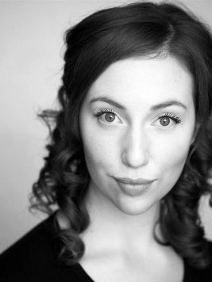
Mary Warren – Laura Riseborough – I chose Laura Harding after watching her play Helena is Midsummers’ Night Dream. Laura had the combination of great hatred acting and sad but, emotional playing. Both of her performances are incredibly convincing even when classed “over-dramatic”.
On Page 46 – Mary enters out of breath, she is exhausted wet and tired. She gets in, sighs with relief and exhaustion, before starting to put her coat away. She is on stage-centre-right and enters through the door positioned by the second wing. John charges towards her and she is now flustered, once again. Make sure to lower posture to make John look more intimidating. After being beaten, clench your “heart area” in pain, meanwhile Marys’ back is turned on John Proctor, both refuse eye contact.
When Mary gives the poppet to Elizabeth they are facing one another. She is feeble and weak-heated throughout this point.
When she tells John about the accused women, she started of calmly, but when declaring the actual number, she speaks loudly, almost in a shout but not quite. She then over-dramatically bursts into tears.
On Page 47 - Make sure to exaggerate the horror on Mary’s face. Between each pause in the line (talking about Sarah Good confessing) make sure to change who Mary is talking to (between Elizabeth, John and the audience).
When, later replying to John make sure to have plain and frank voice; like Mary is stating the obvious.
Stare into Elizabeth’s eyes when saying “She tried to kill me many times…” Say with a sharp tone as well.
On Page 48 – Say the lines calmly, Mary should not raise her voice. It is said like this to create tension later on.


John Proctor – David Tennent – I chose David Tennent because of his large character and his intimidating ways of acting. He brings real presence to the stage when acting and this is exactly who John Proctor needs to be.
John Proctor needs to have a powerful figure. He must be standing upright and use broad, powerful gestures. He walks around as he owns the place. He is incredibly self-confident and does not show any shy or sad expressions during this extract.
On Page 45 – This act is the first time we really see Proctor lose his temper. These arguments build up tension and in the long-term, lead to his death. Stress key words and slow down after large volume. E.g. say “I confessed” loudly and meanly, then turning away with John’s shoulders up, a deep sigh followed by turning around, with upright posture, to face Elizabeth and quietly say with emphasis “confessed”
On Page 46 – Say the first line slower than the others and incredible sharp toned; stress “bear”. After Mary, has entered and settled, use long powerful strides towards her. Throughout shouting at Mary maintain a high position and overlook her as a piece of filth! After these lines move away from Elizabeth and Mary therefore, making you talk from a distance. During each line after get slightly closer. Straight after you refuse to make contact with the others and then you gradually get pulled into the conversation.
On Page 47 – On the first line, no matter whereabouts on the stage John is, he should walk to join the women’s conversation. Say the line with great interest as he moves stealthily across the stage. With the rest of the lines make sure to show great interest, as this is information he does not know about but hr eager to learn.

Extra Parts of the Extract
At the end of Mary Warren’s line “No, sir. There be thirty-nine now” I want her to add around 9 names. As she says their name the outline of the figure will be seen walking across and then standing in a line with their heads down. This will be in the dark with very dim, wing lighting. As they walk across Judge Hathorne will rise. They will be a gap at the centre. Just before Mary says her second line two officials (police officers) walk across holding a woman (at either side). Mary says “Goody Osburn” and the two officials turn around and walk off (whilst Mary is struggling for the words) she then says “will hang” at that moment the lighting turns red, the main characters of the act rush to the sides and pull a grasp expression whilst at a 45° position. Large hanging ropes drop from above. There is some music whilst the freeze frame is held before the lights dye down: the suspects lower their head and walk off and Mary, John Elizabeth return to centre-stage.
The last line of the extract is spoken between three people. Mary Warren starts it off, then the lights go up and Judge Hathorne and Goody Osburn are seen. Judge Hathorne says “Goody Osburn, what cause do you mumble that this girl must fall sick after turning you away?” Goody Proctor then says “Why, your excellence, no curse at all. I only say my commandments; I hope I may say my commandments.” The judge waves his arms and Goody Osburn is taken off.

Set Design and Props
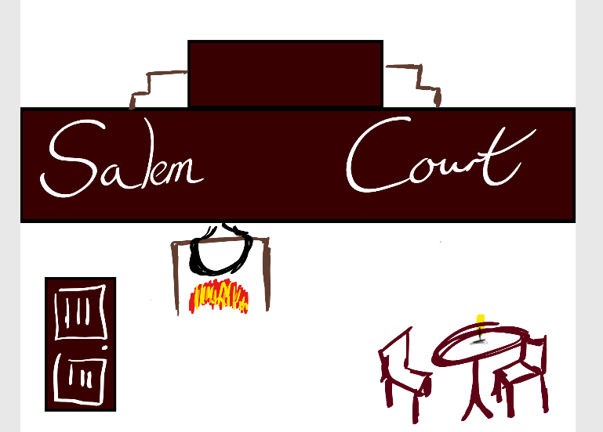
In the background, we see a large wooden platform. On it is written Salem Court. It towers above all of the rest of the props and is at the back of the stage behind the last wing (Wing 3), it is also behind the last curtain (curtain 4) and in front of the back stage white screen. However, the light are down at the back meaning we only see the outline of the towering platform. We can also see the outline of the judge, he appears at “” and then disappears at “”. When he is not on he is hiding under the higher platform. His appearance creates tension as he looks down onto John and Elizabeth Proctor as well as Mary Warren. There is a small table and set of scruffy chairs angled at 45° facing the audience. There is small, black candle (electric) on the table it glows away. A fire place is at back-stage-right. There is a wooden beam holding up a large cauldron. At stage-right by wing 1 is a single wooden, door facing centre-stage at 45°. It remains closed until Mary enters when it is left open and then Elizabeth closes it. The general room is simplistic.
There are no props in this extract apart from the candle, and poppet that Mary Warren gives to Elizabeth Proctor. The poppet is woven, it has a needle stuck in it and does not look put together well. It has buttons for eyes and “x” like stitches for a mouth.

Main Character Costumes
Only the main characters are covered here. Characters like Hathorne, who only appears as a shadow and in light for a line. And, characters the Goody Osburn and the rest of the suspected people, should wear clothes used earlier on in the story e.g. Hathorne is big judge costume and Goody Osburn is poor peasant costume.
The costumes in this scene, like scenery are very simplistic. John’s clothes mostly contain brown clothes that are considered “masculine” and “for the heavy working”. He wears large black boots, that look to be covered in mud at the bottom and soot or dirt and the top; the laces are messily done and do not have a neat appearance. His trousers are rugged and dirty. His shirt is not done up and the first few buttons are undone. His sleeves are rolled up to his elbow, where you can find a thick padding material. He wears a black glove on his right hand (his working hand) and the collar of his shirt is up. John’s hair is long and ragged. He has a lot of dirt across his face and the other skin exposed. His finger-nails are especially dirty with mud and dirt.
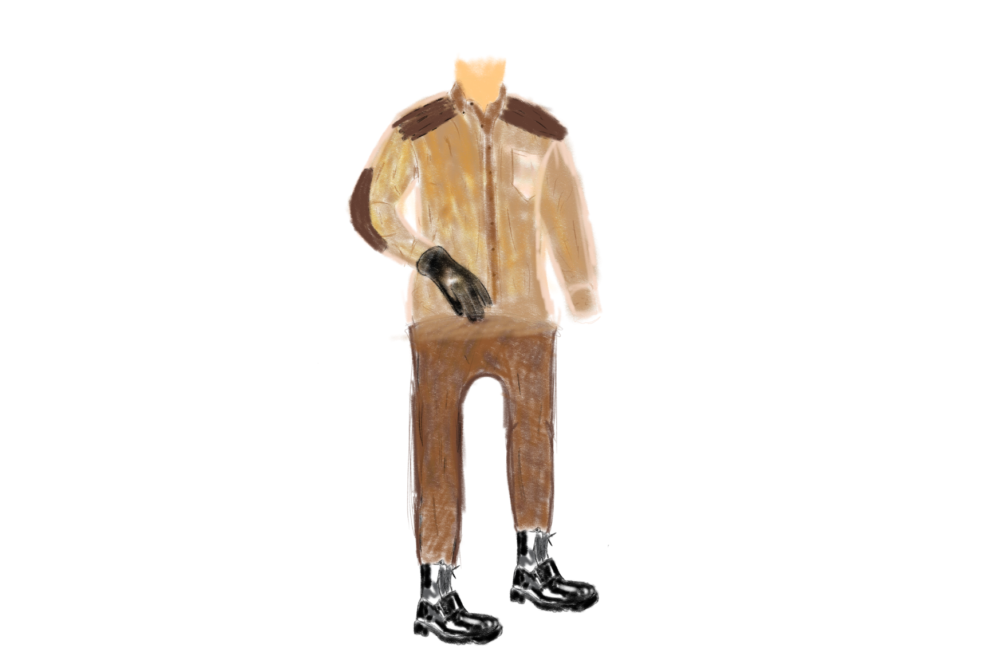

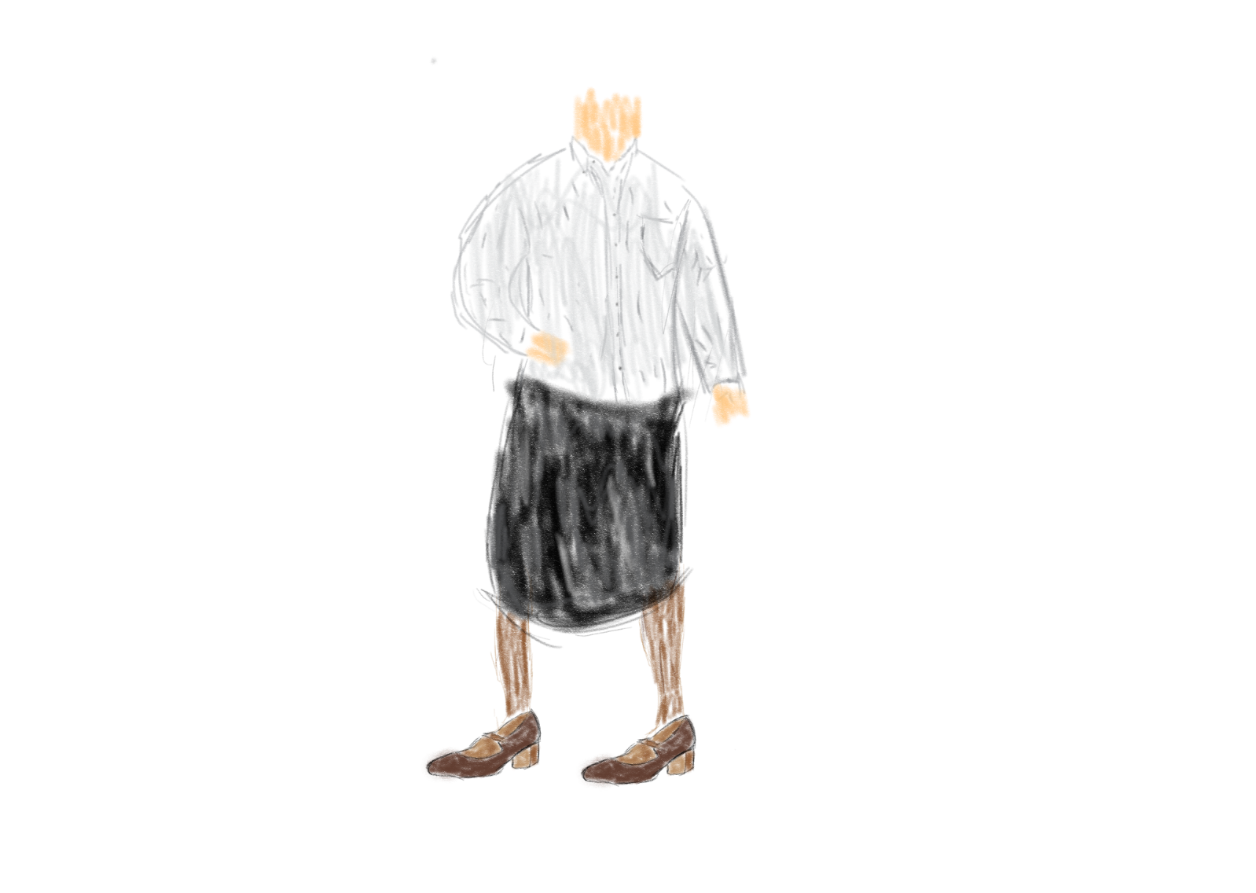
Elizabeth Proctor wear a grey shirt and dresses in a more “presentable” manner compared to John. Her collar is down and all buttons are done up. She wears brown tights and has a large, black cloth apron. That goes from her hips to just below her knee. She has some small pockets in her apron where she keeps kitchen utensils. She wears polished brown shoes with the buckle done up correctly and neatly. Her shirt is tucked in and hair done in a neat bun. We can see her whole face and she does not wear any make-up (accept the necessary stage make-up). She does have some dirt smeared across her face and any skin exposed.
Mary Warren has the same costume as Elizabeth Proctor. The difference is she has black shoes, a little black bonnet. Her shoes are not polished and look slightly scruffy. When she enters, she is wet due to the heavy rain outside. She is not dirty as she has been out in Salem in the court.

Lighting

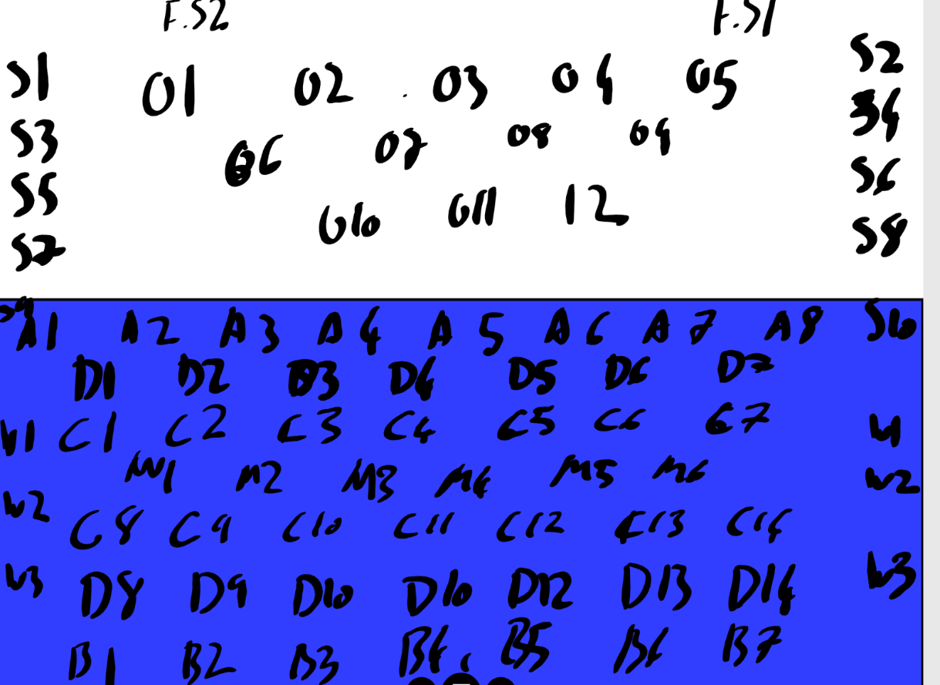
Code | Name | Description | Colour | Intesity
F.S | Follow Spot | Used to highlight specific individuals or objects on stage found at directors box. | White | 6/10
O | Overlooking | Found over audience used to highlight higher areas on the stage. | White | 8/10
S | Side | Found on the upper-sides next to the audience used to highlight to opposite sides. | White | 4/10
A | Alpha | Floodlights or other lower light found at the front of the stage. It is used to highlight the lower half of the actors. | White | 3/10
D | Dynamics | Used to contrast light, setting moods and creating different atmospheres and times of day. | Dark and Light Greens, Blue and Red | 2/10
C | Centre | Found directly above the stage used to face down to highlight items and people. Will be rotating. | Dark and Light Greens, Blue and Red | 5/10
M | Middle | Found at middle of the stage around the second wing. Shines forwards and backwards to cover areas not covered by anywhere else. | White | 5/10
W | Wing | The wing lights are used to highlight entrances and exits as well as possible situations on and off stage. | White | 4/10
B | Back | The back light are used to cover the back of objects creating halo like effects of shadows. | White | 7/10

The extract begins with an intense argument between Elizabeth and John Proctor. Alpha 3,5 and 7 should be on a low light. Dynamic 2,4, and 6 should be on at a dark red. Sides 1,2,7 and 8 should be on. 1 and 7 should be on a higher setting compared to 2 and 8 and should be focused at the door. M1,2,5 and 6 should be on to back the dynamics. B1 and 7 should be on at 10%. Overlooking 10,11 and 12 should be on covering the whole stage. Centre 1,5 and 7 should be on following the characters.
Lighting then changes when Mary enters. Follow spot should be on the door as well as C7. C1 will be on John Proctor. Dynamics 6 turns off and 12,13 and 14 come on at a blue light. Other lighting remains the same.
When the suspects come on all Back goes off except 2,4 and 6 which turn on a 50%. Dynamics 1,3,5 and 7 turn on red others turn off, including rear dynamics. When Goody Osburn comes on A5 turns on at 50% as well as all rear dynamics with a red colour at the same intensity. After they lower their heads all lighting goes off. When main cast is in position Alpha 4,5 and 6 come as well as dynamics 1,3,5 and 7 at a blue light.
Lighting then changes when Hathorne speaks. Back 2,4 and 6 come on at 50%. Previously used dynamics turn to red. All Alpha’s turn off except 1 which turns on to cover Goody Osburn of Stage left. Lights remain on until the conversation ends, this is beyond the end of the extract.

Sound
Minimal sound is used in this extract. A rain SFX should be heard when the door is opened by Mary and goes off when it is closed. A drum should play at a steady pace when the victims come on stage and then when lights go up an immediate dramatic note from the brass section. There should be a high woodwind chromatic scale when the lighting changes from Mary onto Hathorne during page 48. There is no playoff of or on music during this extract.
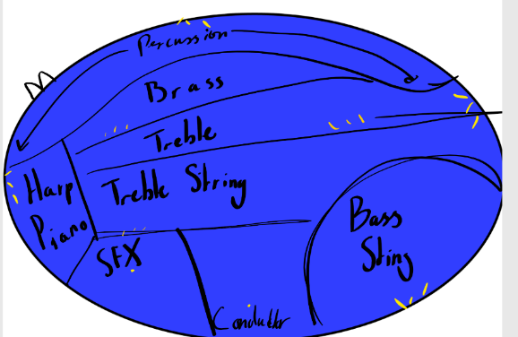
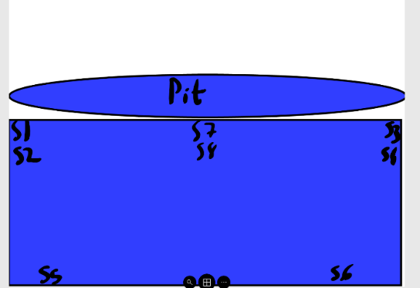
S stands for Speaker. These speakers are used for the SFX but not the orchestra.

