Globalization and Me by Harry Long

To understand the contents of this essay, one must first understand the concept of globalization. Globalization is the way in which we are connected to other through people, countries and companies. Everything you own makes you a globalized person. Globalization originally started when Christopher Columbus sailed over to America, he thought it was India and started taking the food and materials back to Spain. If I am talking over Skype to my Aunt in Australia I will be globalized in two ways. One way is the company theory. You are using Skype® which is designed by Microsoft in Luxemburg City, Luxemburg and Redmond, Washington D.C. It is programmed with over 38 different languages. Another way, which I am using the power of the globe is human contact. I am skyping my Aunt who isn’t where I am. I am not talking to her when she is right next to me. I am using the power of satellites to communicate. Food importation is used nowadays to import and export food that can only be grown in certain countries, to other countries that can’t grow them. Bananas are grown in the tropics of South America but yet when you are in the rainy territory of Great Britain we can eat bananas. Those bananas started out from a seed that would have been genetically modified in a laboratory and then they would be grown by someone using machinery designed by someone else, once they are grown another person brings them over to Great Britain etc… This would only be a small list because one thing is linked to another, it’s like one big international family tree! Everything we own will have a history behind it of people who have designed it, made it, shipped it, delivered it and sold it. From our technology to food and clothes!



In the modern day globalization is not a rare thing to come across. However, there are certain things that people do to help globalization on its mission to connect everyone together. Sharing things these days is very easy to do thanks to web pages, software and applications. You can send a present to someone, by ordering the item on a database like amazon and then directing it to their household. You can share a file by sending it to a fellow user over software like Skype or by attaching it to an e-mail. A more recent way of sharing pictures and videos are social media applications, like SnapChat and Instagram, Twitter and Facebook. These are methods of communication that both the younger and older generation use. Online databases help globalization in many ways. For example if you are buying a mug with a message on for your friend and you are buying it from a shop then you are being globalized. The mug has to be designed by someone, created by someone, bought by a company and shipped to that place. This is a very good example of globalization but we can involve more people by doing it online. If we do it online we have to have:

- Someone to design the product

- Someone to produce the product
Instagram
Founded
October 2010
Twitter
Founded
21/03/2006
- A company to by the product
- Someone to design the website for the company
- Someone to deliver it to a store house
- Someone to create a safe banking system
- Someone to ship the item from the warehouse
Facebook
Founded
04/02/2004
Snapchat
Founded
September 2011
- Someone to collect from the warehouse and put it into the postal system
- A postman to deliver it

We can see how the internet has revolutionised the way we live our lives.
YouTube has changed many things in the human race: Education, work, hobbies and entertainment. Large companies have people who work uploading videos to YouTube for various reasons, companies like Microsoft, Samsung and Apple use it to upload their latest digital advertisements, so that they can influence people to by their products. TV channels and educational sites like ITV and The National Geographic use it to upload documentaries so that schools can teach their students. The largest use for YouTube is entertainment. Gamers and vloggers have become particularly favoured in the past few years. At present a job as a vlogger can be very well paid. However, like the music industry it is difficult to make a living out of it. YouTube, links people together in all of these ways, the user who uploads videos could be in America, and the viewer could be in England. The only thing holding people back from globalization through YouTube is wealth of the country you are in. If you are in a southern African country that is very poor, it is unlikely that you will be able to watch a YouTube video as people just won’t have this technology.

Like anything, globalization has both good and bad aspects about it, so what things are positive about this type of geography? Globalization is a thing all countries do, even if they are poor or rich. Globalization is a way poor countries can become wealthier. Poor countries like Bangladesh create T-shirts and after roughly 30 years or more of making t-shirts the country might start to create more sophisticated things that other countries might want e.g. electronic devices. Globalization gives the opportunity for the inhabitants of poor countries to be employed. Globalization has also improved the way we communicate throughout our everyday life. We can now use Skype, FaceTime and other satellite related communication to talk to people who could be half way across the world. This is good because we don’t have to use up resources like petrol to get to places to meet someone when we could talk to people on a computer instead. Globalization gives us more personal and family time. If we didn’t have people creating our clothes then we would have to create our own clothes reducing the amount of time we would have for family and friends.

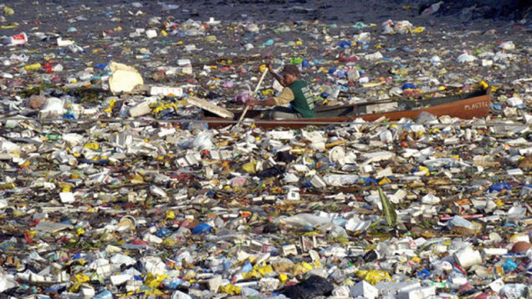
Globalization is a good thing right? What is bad about Globalization? Large companies who put in orders for their product often have their orders placed in poor countries. This is bad because the poor countries won’t be able to by machines; therefore people must work in large (and sometimes unstable) buildings to do the work that machines could do if they were in a richer country. These people who work in large countries get a very low payment of roughly 1$ a day compared to the European standard of 8$ an hour. There is also a higher risk of death than the standard office worker. Richer countries can feel that they are superior because they have been educated and it is the law that you must be educated in certain countries. This is bad because if there were to be an accident the company might deny being a part of it, because they wouldn’t want to be in trouble. People could go on to believe that they are trying to take advantage of their surroundings and treat the poorer people like dumb people. Since the invention of satellite communication people don’t see their friends in foreign countries face to face. It has taken away what little proper socialisation the world has. Cyberbullies have also become a wider subject because of the innovation of technology. Hackers have also become more common and companies like the NSA (the company that wants to have a master key to apple phones throughout the whole world so that they can get into one person’s phone - yeah right) have to take action which may involve to creation of powerful weapons; which other countries would have to make, putting that certain country at risk. Globalization has not helped our environment. Ships that have to carry our products across oceans pollute it with oil, and if they were to sink all of the materials (that could be poisonous to the wildlife) would float off into the ocean. Like the giant Europe sized plastic wasteland that is in the Pacific Ocean. People don’t consider the animals’ which we share our planet with. We should take special care, especially in African and eastern countries that have factories there and endangered animals.

I think globalization makes my life better but at the cost of other people’s life. The human race should learn to share knowledge and abilities but yet at the same time consider other people’s life and become, in a way independent. I do not think this is the same for everyone on the planet. Foreign people rely more on themselves. Furthermore the most independent people are the uncontacted tribes on the continent of South America. They are in no way globalized. Which from a point of view is wrong; what created the human race is the desire to become intelligent which an individual cannot do as well as a group. I couldn’t live without globalization and I think that most people as well couldn’t. The countries that produce our products need us as much as we need them. They need us to buy their craftsmanship, to live and become a wealthier nation. I think globalization is the way forward, the way in which nation will help nation and create a happier environment for all. People should try to be more independent, social and safe yet “many hands make light work”.

